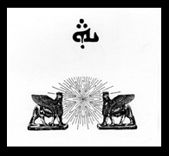©
Naby Frye Assyrian Fund For Culture
15 Tower Hill Road
Brimfield, MA 01010
info@nabyfryeculturefund.org │ 501(c)(3) organization
Application for Grant
(Please limit your application to no more than 4 electronic pages total, double space, 12 pt.)

Name of applicant: Date:
Address:
Email: Tel:
Organization (if applicable):
- Name of Project:
- Purpose (2 sentences):

- Background history of project (limit to one page, double space, 12 pt. font)

- Method of work (limit to one page, double space, 12 pt. font)

- Project Start Date:

- Project End Date:

- Budget:

Amount Requested from NFAFC:

List Names of Other Funder(s):
Amount Financial support from other Funder(s):
- Dissemination of End Product:

